Week In Review: February 1-7, 2002
Alex Shvartsman

Coming Up: Grand Prix-Heidelberg

Pro players got a few weeks off, with only Torment Prerelease to keep them busy. Now that Torment is on the store shelves everywhere, players will get to take it out for a spin at Grand Prix-Heidelberg, Germany. This is the first Grand Prix that will qualify players for Pro Tour-Nice. Sealed deck play on Day 1 will be followed by Odyssey-Odyssey-Torment booster draft on Day 2.
Heidelberg is conveniently located within easy traveling reach of most players at the top of the Player of the Year race. Budde, Baberowski and Blume are sure not to miss a Grand Prix held practically in their back yard. I will travel there and be joined by several other American players, including Pustilnik, Mowshowitz and Kibler. In fact, this will be the first European Grand Prix well-attended by Americans since September. Will Jens Thoren, Farid Meraghni or Tomi Walamies, all near the top of the Player of the Year standings, attend this one to try and earn additional points? None of them traveled to Lisbon, but this GP is closer to home and it is a Limited format.

Coming Up: Event Horizons Invitational
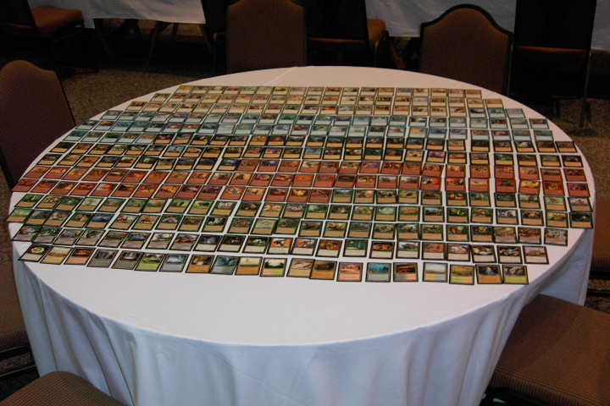
The Rotisserie draft, played at last year's Magic Invitational, debuted at the Event Horizons Invitational
Event Horizons is the tournament organizer for Texas and Louisiana, operated by Tim and Sheila Weissman. For several years now, they awarded their players with an extremely fun event called the Event Horizons Invitational. Based on Mark Rosewater's Magic Invitational, it invites the top (or most popular) players in Texas and Louisiana to compete in the two day long marathon of unorthodox formats.
The Sideboard will cover the event, as it did last year. Although coverage will not be live, you can expect to see it about a week from now. Mike "Potato" Turian will be handling the coverage. Until then, you can visit Event Horizons web page at http://www.evthorizons.com/invitational01.html for more details.

APAC, Latin Championships Canceled
Wizards of the Coast announced this week that they would no longer be holding Continental championships in Asia and Latin America. European Championships will still be held as scheduled. To make up for the loss, WotC will host extra Grand Prix tournaments in those locations. Also, eight invitation slots will be reserved for players from each region based on their DCI ratings. Also, some of the prize money will be diverted to the various National championships in those regions.

Magic Trivia
Last week's question
Who are the only players to have defeated Kai Budde in Grand Prix top 8's?
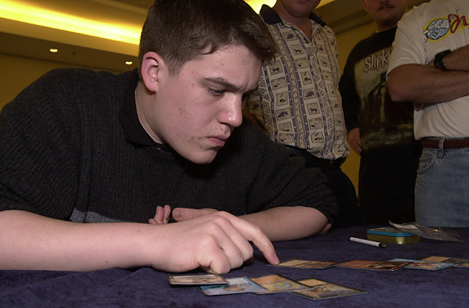
Kai almost always wins in the Top 8
In addition to a very impressive Pro Tour record, Budde has an equally impressive GP record. He has made Top 8 at GPs 8 times and won 5 of them. The only three players to ever take him down, were Craig Jones, Bram Snepvangers, and Nicolas Labarre. Budde's worst Top 8 finish was 3rd place in Grand Prix-Florence, where he lost to Snepvangers in the quarterfinals. His only two other losses were in the finals.
New question:
What Torment card features a reference to a powerful artifact from an older set?
Please do not email answers to me. The correct answer will be posted in the next column.

Play of the Week
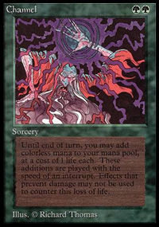
Anyone who has been playing Magic for a long time, or has played Type 1, knows about the Channel-Fireball combo. Kazimierz Koziana was about to be on the receiving end of this powerful play. His opponent played a Mountain and cast a Black Lotus, then sacrificed it for three green mana. He used two to cast Channel paying 19 life, then tapped the Mountainan used the remaining green mana to cast Blaze for twenty. Pretty standard story? Sure, except that Koziana was able to turn the tables on his opponent. He pitched an Accumulated Knowledge to cast Misdirection, leaving his opponent at negative 19 life when the smoke cleared!

Bad Play of the Week
Courtesy of David Coultous:
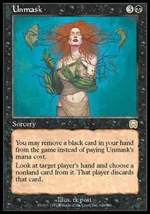
"Probably the worst (and most inexplicable) play I have ever witnessed was in the London Regionals last year. A friend of mine was playing Nether-Go, facing a first round opponent playing blue-black discard. My friend had an opening hand including a Nether Spirit. His opponent went first, playing a Swamp then proceeding to cast Unmask with the alternative casting cost. He removed Lobotomy from the game and took a look at my friend's hand. He quickly recognized the control deck's kill card and chose the Nether Spirit for my friend to discard...
He had paid two cards for the privilege of letting his opponent get his Spirit into play on his first turn... What makes this even more painful was the fact that the one card he had that could really handle the immortal 2/2 (and all its friends) was the one he removed from the game in order to get it into play.

Another Bad Play of the Week
Reported by Alex Anderson:
Jeff showed up at a Neutral Ground Grudge Match qualifier with a Rakavolver-based aggro-control deck. Things were going fairly well for him in game 3, Sacred Ground in play ensuring that he would no longer fear Price of Glory, a sideboard card he saw in the previous game. Despite Sacred Ground in play, Jeff's opponent cast Price of Glory anyway, allowing Jeff access to infinite mana. If that play sounds terrible to you, what do you think of the fact that Jeff, holding two Urza's Rages in hand, failed to recognize that fact, and never cast them with kicker to win the game.
Got an interesting news story, comment, quote, play of the week, or Magic trivia to report? Please e-mail me at ashv80@hotmail.com.

